D

Add cover "' Add comment

**Defining institutional swing points**

Think about ii conceptually

2 forms of swing points, stop run or failure swing

1st swing point is the breaker, make a HH then fail and then break down and have a rejection al the highs. When you have a selling scenraio, generally the market will rally up to resistance it will first fail lo reach that level and break a little lower and then it rallies higher above the STH. When we see price hover below a key institutional reference point, we anticipate price trading to them

* Orderblock example, many times the orderblock is just above and doesn't fill every FVG and then drives up to fill all the FVGs into the OB and then drop

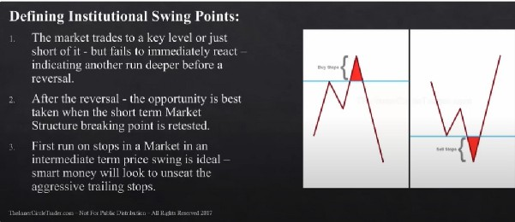

When you have the levels on your chart, youll be able to anticipate a setup unfolding before it actually this with this pattern. If you don't have the levels on your chart youII be surprised

..,.. You can be a seller here at the breaker

Or you can sell it when the stops get taken out but that takes balls and experience

And with this concept, we already had a stop run so theres no reason for that high/low to get taken out Ideally you want to the high/low traded trough to be recent, its fractal, so on the daily its the same

We want to see an immediate response away from the level its traded above/below we don! want it to see it hang there

It doesnt have to go back to give you an entry, depends on how aggressive the move was if the move was super aggressive it will likely not give a pullback Breaker structure is the highest probability

Theres only 2 of viewing the market place when it turns, breaker and swing failure Swing failure:

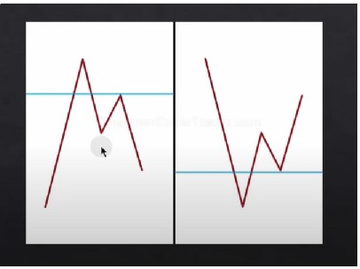It cant take out that blue line. the PD array that we trade above/below

We're aiming for breaker swing points, but if we don! get that we can use this

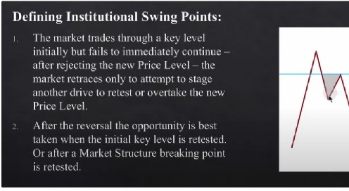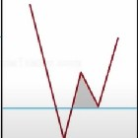

We dont know if ii will give a breaker before we get the swing failure

The SL can be placed above the swing failure. doesnt have to be above the extreme

|  |  |
| --- | --- |
|  |  |
|  |  |

The magnitude at which they move away indicates that theve already trapped sizeable number of orders they wont take out the STH/STL

Breaker is the best, because it allows you to buy/sell in super discount or premium

Notes part 2, second time watching it Breaker pattern is the most powerful

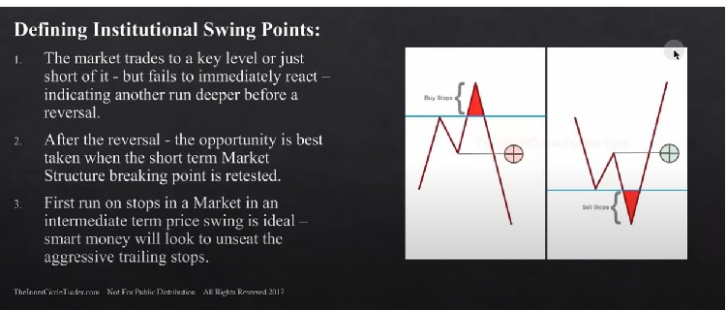When we see price hovering below a key institutional reference point, we anticipate price trading to them

Breaker pattern is basically a small turtle soup

And with breaker pattern you basically get 2 chances of getting in

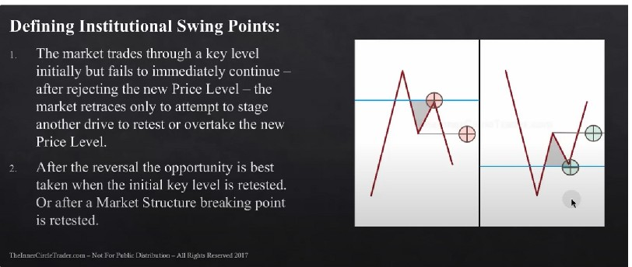

You can put your stop above the failure because it wont allow to trade past that because the funds are trapped there

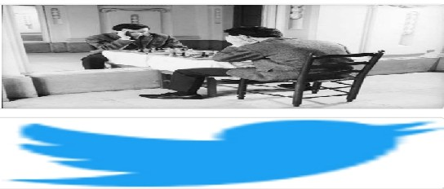Arjo I Twitter, lnstagram I Linktree

Linktree Makeyourlnkdomore htlpsllt.co/HhmmTNln./1

JavaScript is not available.

*'fl* https:/,'twitter.com'arjoio